

TECHNICAL UNIVERSITY OF KENYA

FACULTY OF APPLIED SCIENCES AND TECHNOLOGY

SCHOOL OF COMPUTING AND INFORMATION TECHNOLOGY

DEPARTMENT OF COMPUTER SCIENCE AND INFORMATICS

PROJECT TITLE:

**ENHANCED WIND TURBINE ADAPTED FOR CHANGING WIND DIRECTIONS**

PRESENTED BY:

STUDENT NAME: **MARTIN OWUOR OTIENO**

REG NO: **113/01068**

SUPERVISED BY:

MR. OWIRA & SHADRACK NGUMBAU

PROPOSAL SUBMITTED TO THE SCHOOL OF COMPUTING AND INFORMATION

TECHNOLOGY IN PARTICIAL FULFILLEMENT FOR THE BACHELOR OF TECHNOLOGY IN COMPUTER TECHNOLOGY PROJECT OF THE

TECHNICAL UNIVERSITY OF KENYA

SUBMISSION DATE:

31 January 2025

# **DECLARATION**

I, Martin Owuor, hereby declare that the Project A for ENHANCED WIND TURBINE ADAPTED FOR CHANGING WIND DIRECTIONS presented here is my own original work. This document has been researched and compiled by me and is not copied from any other source. I affirm that all information provided is true and accurate to the best of my knowledge and belief.

Signature,

Martin Owuor  
Date: January 2025

Supervised by,

Supervisor's Signature,

Mr. Owira  
Date:

Mr. Ngumbau  
Date:

# **DEDICATION**

This project is dedicated to my mother, Judith Owuor and my late dad Mr. Amos Owuor, who have supported me and been with me through thick and thin. Your belief in my abilities and your encouragement have propelled me forward in achieving my goals.

# **ACKNOWLEDGEMENT**

I thank God for His strength, guidance and provision in completing this Project A for ENHANCED WIND TURBINE ADAPTED FOR CHANGING WIND DIRECTIONS.

I also thank my lecturers and supervisors, Mr. Owira and Mr. Shadrack, for their continuous support and guidance throughout this project. I dearly appreciate my dear mother who has always gone out of her way to ensure that I’m able to pursue my studies.

# **LIST OF ABBREVIATIONS**

AC – Alternating Current

App – Application

DC – Direct Current

DFD – Data Flow Diagrams

ERD – Entity Relationship Diagrams

GPS – Global Positioning System

IoT – Internet of Things

KenGen – Kenya Electricity Generating Company

KES – Kenya shilling

MW – Megawatts

PLC – Programmable Logic Controller

RPM – Revolutions Per Minute

SCADA – Supervisory Control and Data Acquisition

SDG – Sustainable Development Goal

UN – Unted Nations

UI – User Interface

UPS – Uninterruptible Power Supply

Wi-Fi – Wireless Fidelity

# **LIST OF FIGURES**

Figure 1: Gantt chart ----------------------------------------------------------------------- 6

Figure 2: Data Flow Diagram ------------------------------------------------------------- 6

Figure 3: Data Flow Diagram ------------------------------------------------------------- 6

Figure 4: Context Diagram ---------------------------------------------------------------- 6

Figure 5: Use Case Diagram -------------------------------------------------------------- 6

Figure 6: Entity Relationship Diagram -------------------------------------------------- 6

# **LIST OF TABLES**

Table 1: Budget and Resources -------------------------------------------------------------------------- 5

# **TABLE OF CONTENTS**

**DECLARATION** ii

**DEDICATION** iii

**ACKNOWLEDGEMENT** iv

**LIST OF ABBREVIATIONS** v

**LIST OF FIGURES** vi

**LIST OF TABLES** vii

**TABLE OF CONTENTS** viii

**ABSTRACT** x

**CHAPTER ONE: INTRODUCTION** 1

**1.1 Introduction** 1

**1.2 Background of the Study** 1

**1.2.1 Background of the Organization** 1

**1.2.2 Overview of the Existing System** 1

**1.3 Overview of the Proposed System** 2

**1.4 Problem Statement** 2

**1.5 Objectives** 3

**1.5.1 Project Goal** 3

**1.5.2 General Objectives** 3

**1.5.3 Specific Objectives** 3

**1.6 Justification** 3

**1.7 Scope of the Study** 4

**1.8 Limitations of the Proposed System** 4

**1.9 Project Risk and Mitigation** 4

**1.10 Budget and Resources** 4

**CHAPTER TWO: LITERATURE REVIEW** 8

**2.1 Reviewed Similar Systems** 8

**2.2** **Tools and Methodologies Used in Reviewed Systems** 9

**4.7** **Gaps in Existing Systems and the Proposed Solution** 9

**4.7** **The Proposed Solution** 10

**CHAPTER THREE: METHODOLOGY** 11

**4.7** **Methodology and Tools** 11

**3.2 Sources of Data** 12

**4.7** **Data Collection Methods** 13

**4.7** **Resources Required / Materials** 13

**CHAPTER FOUR: SYSTEM ANALYSIS AND REQUIREMENT MODELING** 14

**4.1 Introduction to the System Analysis** 14

**4.2 Objectives of the System Analysis** 14

**4.3 Problem Definition** 14

**4.4 Feasibility Study** 14

**4.5 System Analysis Tools** 15

**4.6 System Investigation** 18

**4.6.1 Introduction** 18

**4.6.2 Data Collection** 18

**4.6.3 Fact Recording:** 19

**4.7 System Analysis** 20

**REFERENCES** 22

# **ABSTRACT**

An Internet of Things-based solution for maximising wind turbine operational efficiency at KenGen's Ngong Hills Wind Power Plant is presented in this project proposal. The technology tackles issues that impair energy production and operational reliability, such as incorrect turbine alignment, frequency instability, and shutdowns at high wind speeds. Utilising technologies like GPS, Wi-Fi, IoT sensors, and PLCs, the system stabilises electricity frequency, allows automated turbine alignment, and adds an electric brake mechanism to avoid shutdowns during strong winds. Furthermore, remote control and real-time turbine operation monitoring are made possible using an Android application.

The proposed arrangement coordinating stack cells to sense wind course, engines for energetic arrangement, and criticism components to preserve consistent rotational speeds. A Waterfall Demonstrate guides the system's improvement, guaranteeing organized advance from necessity examination to usage. The extend is adjusted with feasible improvement objectives and Kenya's Vision 2030, pointing to diminish dependence on fossil fills and upgrade renewable vitality utilization.

The expected benefits incorporate expanded vitality generation, decreased upkeep costs, and consistent framework integration. The evaluated fetched of usage is KES 15,000, with a timeline of six months for framework advancement and testing. This activity offers a versatile and effective approach to modernizing wind vitality frameworks.

# **CHAPTER ONE: INTRODUCTION**

## **1.1 Introduction**

The 'Enhanced Wind Turbine Adapted for Changing Wind Direction' project aims to address operational inefficiencies in wind turbines, such as KenGen's Ngong Hills Wind Farm. Wind turbines work by converting wind energy into electricity through mechanical and electromagnetic processes (Ackermann, 2019). However, suboptimal turbine alignment, inconsistent power frequency, and outages at high wind speeds are persistent challenges (Sharma et al., 2020). These issues prevent maximizing energy production and disrupt power supply, requiring innovative solutions. The system uses GPS, Wi-Fi, and PLC technology for automated control and remote monitoring, ensuring turbines are aligned with the prevailing wind direction (Zhang & Bauer, 2021).

## **1.2 Background of the Study**

### **1.2.1 Background of the Organization**

KenGen’s Ngong Hills Wind Farm was built in 1993 and is located approximately 30 km southwest of Nairobi, Kenya. The power plant began operating at a modest capacity and has become a significant contributor to Kenya’s renewable energy industry (International Renewable Energy Agency [IRENA], 2020). Initially featuring only a small number of turbines, the facility has since expanded to over 30 turbines with a total capacity of over 26 MW (Kenya Electricity Generating Company [KenGen], 2021). The power station’s strategic location takes advantage of the strong, consistent winds that prevail in the Ngong Hills region.

KenGen’s mission to provide Kenya’s growing population with reliable, sustainable and renewable energy has highlighted the importance of optimizing operations. Growing energy demands and the need for seamless grid integration have led to the introduction of modern technologies to improve efficiency and reliability (Otieno & Wekesa, 2022.

### **1.2.2 Overview of the Existing System**

The Ngong Hills Wind Power Plant currently uses conventional turbine control mechanisms to match turbines to wind direction, keep track of performance and coordinate grid connection. But though efficient, these are still manual-driven processes that need to be updated and continuously checked, and are therefore subject to lags and waste. The SCADA will enable the operators to control and monitor the turbines from far away for increased flexibility (Zhang & Bauer, 2021).

The turbines at the plant tend to shut down

when the wind is blowing in excess so that they don’t cause mechanical damage, and this will reduces energy generated (Sharma et al., 2020). There are also electricity frequency fluctuations that make grid integration more difficult and limited operations can be done remotely with an on-site technician (Otieno & Wekesa, 2022).

Challenges identified:

* Improper alignment of the turbine to face the oncoming wind.
* Turbine coming to a halt during excessive high winds.
* Varying current frequency in changing winds speeds.
* Inadequate abilities to control the turbines remotely.

## **1.3 Overview of the Proposed System**

Through this IoT based-solution, there will be real-time monitoring and mechanisms to control the turbines thus enhancing turbine operations:

1. **Turbine Alignment Optimization:** There are IoT sensors that will monitor wind direction and automatically align the turbines to always face the oncoming wind. The system will deploy DC motor to facilitate the turbine alignment (Gupta, Sharma & Patel, 2020).
2. **Keeping AC Frequency Constant:** This will be achieved through feedback control mechanism. Basically, achieving a constant RPM (Robinson & Lee, 2022).
3. **Preventing Shutdowns in Excessive Winds:** Even when the wind is high, an electric braking system will be deployed to reduce the speed to optimum range thus the turbine will not shut down completely (Zhang, Liu & Tang, 2021).
4. **Remote Control Capabilities:** An Android app will be developed, integrated with Arduino and through Wi-Fi, there will be remote control of the turbines so as to overcome any delays in cases where technicians have to manually start the turbines (Thompson & Patel, 2023). The existing systems deploy SCADA for remote monitoring but does it has not been incorporated in smart phones.

## **1.4 Problem Statement**

KenGen’s Ngong Hills Wind Power Plant is doing well; however, there a few challenges pertaining energy maximization and making their operations more efficient. These challenges are primarily due to;

1. Inefficient alignment of the turbine to face the oncoming wind direction all the times (Smith & Davis, 2021).
2. Turbines having to shut down in excessive wind thus no power generation hence losses (Adams & Wang, 2020).
3. Varying electricity frequencies thus difficulties in integrating into the grid (Chen & Li, 2019).
4. Inability to power the turbines remotely hence time wastage (Gonzalez & White, 2022).

This project will address the mention issues by proposing IoT based solutions for providing remote control, automation and capabilities for real-time monitoring.

## **1.5 Objectives**

### **1.5.1 Project Goal**

To design, build and implement a system that is IoT powered hence enhancing efficiency, reliability and flexible operations of the turbine, specifically, for the KenGen’s Ngong Hills Wind Power Plant.

### **1.5.2 General Objectives**

To design, build and implement a system that is IoT powered hence enhancing efficiency, reliability and flexible operations of the turbine, specifically, for the KenGen’s Ngong Hills Wind Power Plant.

### **1.5.3 Specific Objectives**

1. To implement IoT powered sensors that will automatically align the turbines to face the oncoming wind all the times.
2. To develop an Android app that will allow the technicians to control the turbines remotely.
3. To build contactless electric braking system.
4. To stabilize the frequency of electricity generated

## **1.6 Justification**

This is a timely project and it is in a perfect alignment with the UN’s SDGs by deploying the technology that powers IoT to maximize energy production from wind which is a renewable source of energy (United Nations, 2019). If the Ngong Hills Wind Power Plant becomes more efficient and reliable, then there will be a relief on other energy sources especially fossil fuels thus consumers may be able to enjoy reduced electricity bills. Last but not least, this project is in support of Kenya’s Vision 2030 sustainable development agenda; reliable energy, and reducing dependency on fossil fuels.

## **1.7 Scope of the Study**

The project covers development and deployment of an IoT system to boost operations of wind turbines at KenGen’s Ngong Hills Wind Power Plant. The specific coverage areas include the following:

* Optimizing turbine alignment to face the oncoming wind all the times.
* Ensuring that the frequency of electricity is constant.
* Keeping the turbine operational even in high winds.
* Remotely operating the turbines by using an Android App.

However, in this study, other than wind energy no other renewable energy source is of interest and any solution that is not IoT based is not covered.

## **1.8 Limitations of the Proposed System**

* Insufficient financing may limit the project’s scope and the scale at which the system is deployed.
* Due to time constraints, system testing and validation may be adversely affected (Ali & Baig, 2021).
* Arduino is Wi-Fi powered thus there is need for a reliable internet connection (Vujović & Maksimović, 2020).

## **1.9 Project Risk and Mitigation**

* **Risk:** Hardware components may fail (Madakam et al., 2019).
  + **Mitigation:** Buy components from a reliable vendor and test them extensively.
* **Risk:** Software development may take longer time than expected.
  + **Mitigation:** Adopt agile software development strategies (Sommerville, 2019).
* **Risk:** KenGen may cling to their old system and reject this proposal.
  + **Mitigation:** Train effectively and show benefits over challenges.

## **1.10 Budget and Resources**

The project will require:

* **Hardware:** IoT sensors, Arduino, motors, laptop, electromagnet and controllers (Dorsemaine et al., 2019).
* **Software:** Android IDE, and cloud platforms.
* **Human Resources:** System developers, electrical technicians, and IoT experts.
* **Estimated Cost:** KES 15,000 excluding labour.

|  |  |  |  |  |
| --- | --- | --- | --- | --- |
| **RESOURCES** | **DESCRIPTION** | **SPECIFICATIONS** | **UNITS** | **PRICE** |
| Laptop | For the coding of the web-based application | Minimum requirement of a HP core i5, RAM 4 GB and storage space of  500GB | One | Ksh 40,000  (Available) |
| Mobile phone | To do testing | Smartphone | One | Ksh 8,000 (Available) |
| IoT Hardware | For control | ArduinoNode MCU ESP2666, Load cell | One | Ksh 12000 |
| Cloud backup storage | To back up the progress of the web- based application | At least 15 GB | One | GitHub (Free) |
| Antivirus | To protect the laptop from viruses that  may destroy the data | Kaspersky anti-virus | One | Ksh 2,000 (Available) |
| Miscellaneous | Typing, printing cost throughout the  project | - | - | Ksh 3,000 |
| Manpower | To build the system | - |  | Free |
| TOTAL |  |  |  | =Ksh 15,000 |

**Table 1: Budget and Resources**

**Project Schedule and Cost:**

* **Time Schedule:** 6 months are projected to be enough for the project:
  + Analysis of the Requirements: 1 month
  + System Design: 1 month
  + Implementation and coding: 2 months
  + Testing, fine-tuning and Deployment: week.
* **Cost Estimation:** KES 15,000, covering hardware and software components, and human resources.

**Project Gantt Chart**

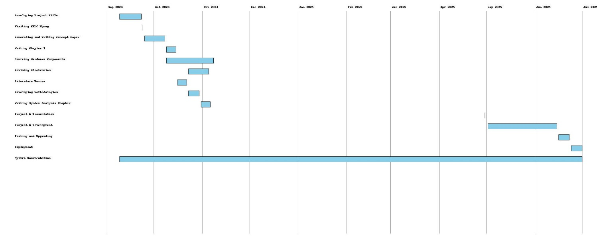

**Figure 1: Gantt chart**

Time frame - September 9th 2024 to November 30 2024 then a break Resume February 14th 2025 to May 30th 2025.

Task 1: Developing Project Title (Duration: First two weeks from the 5th September 9th 2024 )

Task 2: Visiting KPLC Ngong (Duration: 1 day - on 24th Sep 2024)

Task 3: Generating and Writing Concept Paper (Duration: The next 2 weeks after completing task 2)

Task 4: Writing Chapter 1 (Duration 1 week: begins after completing task 3)

Task 5: Sourcing hardware components (duration 1 month begins after completing task 3)

Task 6: Revising Electronics (Duration 2 weeks: Begins 2 weeks after starting task 5)

Task 7: Literature Review (Duration: 1 week: begins after completing task 4)

Task 8: Developing Methodologies (Duration: Begins after completing task 7)

Task 9: Writing System Analysis Chapter (Duration 1 week: Begins after completing task 8)

Task 10: Project A Presentation (Duration 1 day: 30th April 2025)

Task 11: Project B Development (Duration 1.5 months beginning 2nd May 2025)

Task 12: Testing and Upgrading (1 week after completing task 11)

Task 13: Deployment (1 week after completing 12)

Task 14: System Documentation (Duration from day 1 to last day)

# **CHAPTER TWO: LITERATURE REVIEW**

## **2.1 Reviewed Similar Systems**

There have been a number of systems developed to make the wind turbines operate efficiently. Some of the developments focus on optimal turbine blades alignment to face the oncoming wind all time though little attention goes to constant frequency output and remote control. The developments include;

1. **IoT-Enabled Wind Turbine Solutions**

(Teimourian et at., 2022) described detailed IoT powered system that automatically aligns the turbine blades to the oncoming wind. Their system used sensors to sense wind direction and then send signals to effect turbine alignment outdoing the need to manually make the adjustments hence improved quantity of electricity generated. Even though it was a leap forward, it had nothing to mention about the frequency of electric current generated making it a nightmare to integrate with the national grid.

1. **SCADA Control for Adaptive Wind Turbine**

According to (Mahmoud & Oyedeji, 2019), SCADA efficiency is undeniable and very effective in mind power plants. They propped an adaptive SCADA-based control to be used on turbines to enhance alignment. It would have remote system abilities but it relied mostly on the structures that are available at the site making its flexibility limited. At the end of the day, it remains a proposal because it is not clear whether the system was implemented anywhere since it is very costly.

1. **Wind Turbines to Manage Load Dynamically**

Dynamic Load Management of turbines is suitable for ensuring that a wind power station would never have to shut down completely in excessive winds (Kim, Kim & Kim, (2020). The proposed system deployed dynamic braking system is associated with excessive wear and tear making turbine components run out frequently thus accruing additional maintenance cost raising sustainability concerns in this proposal.

## **Tools and Methodologies Used in Reviewed Systems**

1. **IoT-Enabled Wind Turbine Solutions**

* **Tools:** Wind sensors for detecting and sensing wind direction, PLCs for processing wind signals and manipulating the turbine alignment, and cloud computing platforms to enhance remote control functions (Salhaoui & Arioua, 2018).
* **Methodology:** Acquiring data instantaneously and aligning the turbine automatically.
* **Advantages:** Efficient turbine alignment and time saving due to automation.
* **Disadvantages:** Does not give much attention to stabilizing frequency and unstable internet connection may halt the operations.

1. **SCADA Control for Adaptive Wind Turbine**

* **Tools:** SCADA-based systems and servers available locally (Kumar & Singh, 2019).
* **Methodology:** The control is done from a central point and continuous data analytics.
* **Advantages:** Reliable monitoring is more possible and easy recovery from the detected faults.
* **Disadvantages:** It is not cost effective and rely heavily on the infrastructures available onsite.

1. **Wind Turbines to Manage Load Dynamically**

* **Tools:** Load sensors/cells to determine how much force is need to slow the system and braking systems like disk brakes to slow down the system.
* **Methodology:** Avoids overloading by monitoring the system in real-time.
* **Advantages:** The wind turbine will work optimally even in the extreme winds.
* **Disadvantages:** Rapid wear and tear shoot the maintenance cost

## **Gaps in Existing Systems and the Proposed Solution**

**Identified Gaps:**

1. **Remote Control Feature is Limited:** SCADA system is used to address the remote monitoring but it is not available in mobile platforms. Moreover, it simply monitors but you cannot start the system over SCADA (Ahmed et al., 2020).
2. **Stabilizing the Frequency of Generated Electricity:** The existing systems have nothing much to do with making the frequency of generated electricity constant. Thus, it is a huge challenge to integrate the wind energy into the national grid (Ahmed et al., 2020).
3. **High Cost:** Most existing systems are just proposal and require intensive capital investment and maintenance. This huge money may be reflected on consumer end as elated bills making the fossil fuel cheaper than wind energy (Ahmed et al., 2020).
4. **Durability:** Dynamic braking concept is associated with high wear and tear reducing the turbine lifespan and high maintenance cost (Ahmed et al., 2020).

**Proposed Solution:**

* Modifies load cells to sense wind direction and rotates a motor to automatically align the turbines.
* Feedback mechanism to fix the frequency of current at a constant value.
* Electric braking mechanism to ensure turbine operation even in high winds and minimizing wear and tear at the same time.
* An Android app to for remote control hence time saving, efficiency and flexibility.

## **The Proposed Solution**

The identified gaps mentioned above can be addresses by the proposed system as elaborated below:

1. **Aligning the turbines automatically to face the oncoming wind:** Turbine blades adjust themselves as the wind changes direction. This is done by using load cells modified to sense wind direction, the signal is output on Arduino pin to a motor which then rotates the entire turbine assembly.
2. **Stabilizing frequency:** fixing the RPM by deploying braking and adjusting exciter current.
3. **Optimal operation in high winds:** by deploying electronic braking system with no physical contact thus eliminating wear and tear.
4. **Remote Control:** building an android app.

# **CHAPTER THREE: METHODOLOGY**

In this chapter, the framework and techniques guiding the development of the wind turbine which has proposed is outlined. It also highlights the methods used to collect data and tools used as well as the necessary resources required.

## **Methodology and Tools**

The most ideal development methodology that the system will deploy is Waterfall Model. This is because Waterfall Methodology guarantees the system development approach to be structured and sequential (GeeksforGeeks, 2025). Waterfall Model is divided in phases where a later phase is built upon the former phase meaning that the requirements gathering, deployment and maintenance have a clear roadmap.

**Waterfall Model Phases:**

1. **Requirements Analysis**
   * Identifying the needs of the users who are the engineering technicians. Defining the system requirements which are based on the challenges the technicians are facing at the KenGen’s Ngong Hills Wind Power Plant.
   * Outputs: Clear documentation of functional and non-functional requirements.
2. **System Design**
   * Designing architectural plans and detailing the expected designs. The suggested tools for system design include; ERD, DFD and Flowcharts.
   * Outputs: Architectural System Design and the designs of the necessary modules.
3. **Implementation**
   * Assemble the actual hardware components of IoT and build a prototype of an actual wind turbine to a defined scale.
   * Use programming languages such as Java, Kotlin and Python for IoT and Android programming to code the expected system.
   * Incorporate the IoT associated components such as amplifiers and sensors into the system.
4. **Testing**
   * Conduct different types of testing at each stage of the Waterfall Model, for example, unit testing, integration testing and system testing so that there can be certainty that the system is functioning, performing and reliable.
   * Tools: Selenium to test the Android application, and MQTT to test the IoT components.
5. **Deployment:**
   * The system will not be deployed at Ngong Hills Wind Power Plant since it will be a small-scale portable prototype mean for demonstration.
6. **Maintenance:**
   * Continuous support provision to ensure all time operability.

**Reasons why the System is built on Waterfall Model:**

1. The objectives and scope of the project align well with Waterfall Model structured approach.
2. Along the way at each phase, the system can extensively be documented thus reducing chances that may lead to omitting crucial requirements.

## **3.2 Sources of Data**

**a. Primary Data**

* One on one interviews with the with the Engineers, technicians and manages to gain insight into how their plan works including the operational requirements, the challenges they face running the power plant as well as the business aspect of the system.
* The data the IoT sensors will transmit in real-time while the prototype will be undergoing testing.

**b. Secondary Data**

* Research articles, user guide manuals, publications in magazines concerned with energy and people document their endeavours and achievements in Wind Energy and IoT systems.
* The SCADA outputs in its logs as Ngong Wind Power Plant Technicians receive them.

## **Data Collection Methods**

1. **Interviews**

* Carry out structured interviews with the engineers and technicians at Ngong Hills Wind Power Plant to understand the shortcomings of the existing systems and the requirements of the user (Abawi, 2017).

1. **Questionnaires:**

* Issue in depth questionnaires the people involved in the power plant to understands the challenges in operating the power plant and what they should expect.

1. **Observation:**

* Look at the power plant while operational and identify what seems ineffective and come up with ways to make it better.

1. **Review Document**

* Examine the past records to see how the system has been performing. SCADA logs can help establish a difference in pattern when compared with past records.

## **Resources Required / Materials**

**Hardware Specifications:**

* **IoT Sensors:** Load cell, amplifier.
* **Controllers:** Arduino NodeMCU ESP 8266.
* **Motor:** permanent magnet DC motor.
* **Server:** Cloud-based server hat a minimum of 16GB RAM, Core i7 or Rayzen processor, and 1TB memory space.

**Software Specifications:**

* **Operating System:** Windows Server 2016 or above to host the project in the cloud and Windows 10/11 for running Android Studio and Arduino IDE.
* **Development Tools:**
  + Android Studio and Arduino IDE.
* **Testing Tools:** Selenium to test the Android app.
* **Security Software:** Updated Avast antivirus and Windows Firewall.

# **CHAPTER FOUR: SYSTEM ANALYSIS AND REQUIREMENT MODELING**

## **4.1 Introduction to the System Analysis**

System analysis delves into the working of the Wind Turbine and helps the reader understand how KenGen Ngong Hills Wind Power Plant engineers and technicians control and monitor the wind turbines (Ten & Hou, 2024). It also gives a leap into the challenges the technicians and engineers face making the power plant inefficient which led to the development of an Enhanced Wind Turbined Adapted for Changing Wind Directions.

## **4.2 Objectives of the System Analysis**

1. Evaluating what the current system can do and its challenges.
2. Come up with challenges specific to the operation.
3. Define what the new system will require.
4. Ensuring that the proposed system is in line with the user requirements and realizable technically (Ten & Hou, 2024).

## **4.3 Problem Definition**

Below are some of the challenges that the Ngong Hills Wind Power Plant face:

1. Inadequate alignment of the turbines to face the oncoming wind all the time.
2. During excessive winds, the system has to shut down completely.
3. Changing electricity frequency making it difficult to integrate into the national grid (Azlan et al., 2021).
4. Inability to start the systems remotely.

## **4.4 Feasibility Study**

A feasibility study examines whether the proposed system will be achievable technically, economically, operationally and in terms of time schedule.

**Technical Feasibility:**

* Technology needed to accomplish this project is within reach, for example IoT Sensors, Arduino IDE and Android Studio are mature technologies allowing integration and compatibility with the different components required.
* Technologies in the cloud also allow real-time system monitoring.

**Economic Feasibility:**

* The project is estimated to cost Kes. 15,000 which cheap and equally affordable.
* The project has a potential increase energy output and ensure uptime hence justifying the Kes. 15,000 investments.

**Operational Feasibility:**

* The project’s goals are in agreement with what KenGen wants to achieve, that is, efficiency and sustainability.
* The systems deployment will not disrupt the existing systems hence smoother system changeover.

**Schedule Feasibility:**

* The timeline that has been proposed to be 6 months is enough to take of system development all through the deployment phase (Ten & Hou, 2024).

**Feasibility Report:** After examining the stated factors above, one can conclude that the project is feasible and its potential to address the existing challenges and maximize efficiencies is high.

## **4.5 System Analysis Tools**

The system modeling and analysis will deploy the following tools;

* **Flowcharts**

Shows how the current system and proposed system work step-by-step. The reader is able to visualize how the turbine aligns itself to always face the oncoming wind, and also how it triggers the electronic braking system to stabilize the frequency of the generated current and ensuring that the turbine does not shut down in excessive wind.

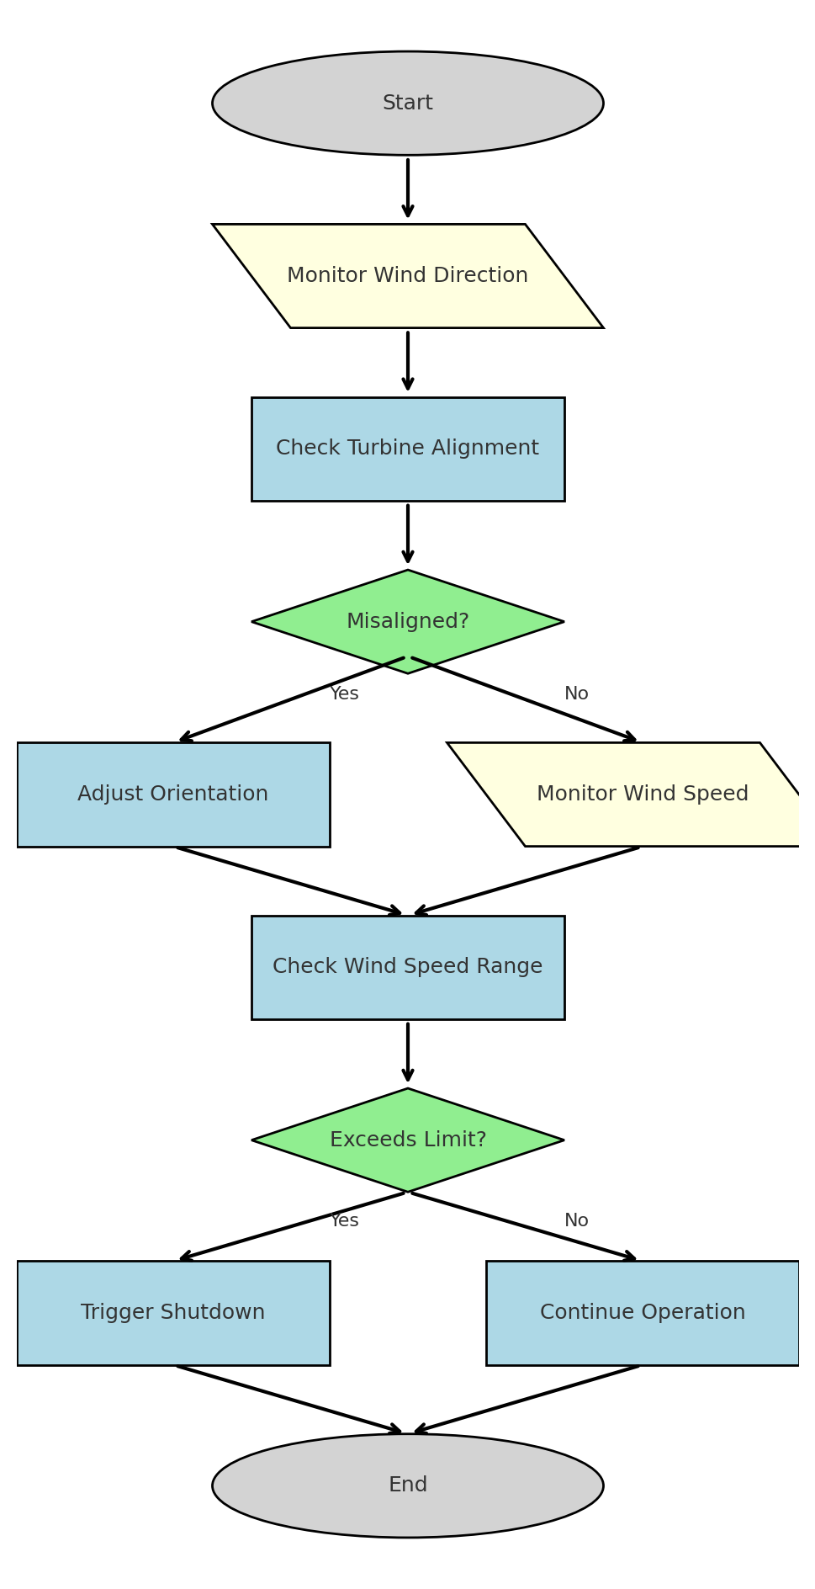

Fig. 2 Flow Chart

* **Data Flow Diagrams (DFDs)**

Shows how the data moves from its source, among processes and how it is stored and retrieved. Primary data here are wind direction and speed. Wind direction activates signals to align the turbine blades while the wind speed activates or deactivates the braking system.

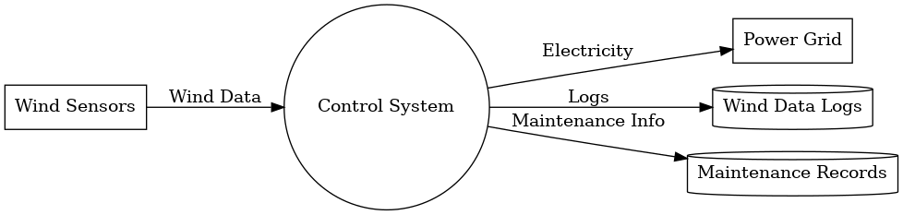

Fig. 3 Data Flow Diagram

* **Context Diagrams**

Shows the interactions between the system and external entities. For example, if the turbines are currently facing north while wind is coming from the west, then west facing load cell is activated and D1 pin of NodeMCU ESP 8266 sends current to the base of the transistor and it current drives the motor to face west.

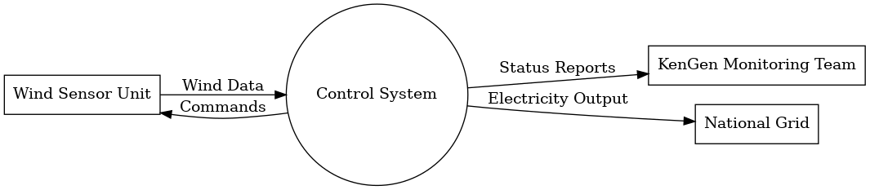

Fig 4. Context Diagram

* **Use Case Diagrams**

Shows the interactions between the system and its users. The users of the system are the technicians and engineers who interact with the system on daily basis for maintenance, monitoring and optimization. This can extend the placement of control buttons on the Android app UI.

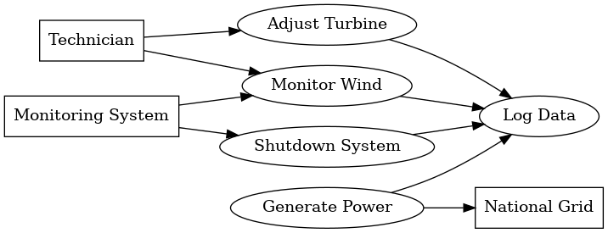

Fig 5. Use Case Diagram

* **Entity Relationship Diagrams (ERDs)**

Defines how data within the system relate. There is a 1 to many as a kind of relationship, for example, wind speed affecting the frequency of the generated electric current and engagement and disengagement of the electric brake.

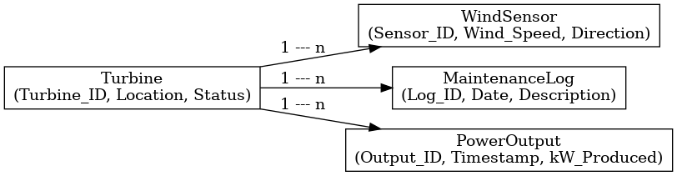

Fig 6. Entity Relationship Diagram

## **4.6 System Investigation**

### **4.6.1 Introduction**

System investigation aims to gather and record data with the objective of understanding how the already existing works, its changeless and developing solutions to optimize its operations.

### **4.6.2 Data Collection**

Here are the methods that will be deployed to collect data:

1. **Interviews:** Performing one on one interviews with the engineers and technicians to understand how the existing system works and the challenges they are facing running the system. Also, to insights into what they would like improved to make their work easier and create a conducive workplace for them.
2. **Questionnaires:** Gives the input gathered from the various stakeholders. Also, the engineers and technicians can have questionnaires to give their in-depth perspective of what modifications they want to see incorporated in the system.

1. **Observation:** Watch the turbines rotate and note any inefficiency. Watch the technicians perform their routine tasks, take note of time they take for each task or a particular area. If they more time in a particular area or task, then it means that the area needs much attention on improvements.

1. **Inspection Records:** Identify patterns and gaps that the SCADA data logs my exhibit. Look for cracks in the turbines and check for wear and tear in the existing braking systems.

### **4.6.3 Fact Recording:**

1. **Methods:**
   * Forms: This will record the specific requirements of the system.
   * Narratives: From the interviews and observations, summary will be obtained.
   * Diagrams: Process visualization through charts and DFD.
2. **Program Requirements:**
   * **Input Requirements:** Direction of wind, speed of wind data, and commands from the operator.
   * **Output Requirements:** How the turbines are aligned (their status), frequency of the generated electricity, and performance metrics.
   * **Process Requirements:** Data analysis in real-time, feedback mechanism and control, and how to adjust the system.
   * **File Requirements:** Operational logs and configuration data storage.
   * **System Requirements:** IoT (Load cell) sensors, PLCs, and Android applications for monitoring.

## **4.7 System Analysis**

**Analysis of the Program Requirements**

There are some components of the existing systems that might find use in the proposed system; therefore, the analysis of the current system requirements will be carried out. Whatever the outcome of the finding in the system, it will be carried forward into the proposed system (Ten & Hou, 2024).

**Modeling Tools:**

* **System Flowcharts:** Shows how the current system and proposed system work step-by-step. It walks the users over the system and how the turbines react to the direction of the oncoming wind to change its orientation.
* **DFDs:** Shows how the data moves from its source, among processes and how it is stored and retrieved. Data from wind direction into the load cells to NodeMCU to effect motor rotation to align the turbine blades.
* **Use Case Diagrams:** Shows the interactions between the system and its users. Here the technicians and the engineers who are the primary users of the system are able to press a button on their Android mobile app and start or stop the turbines remotely.
* **UML Diagrams:** Defines how data within the system relate. For example, the frequency of the generated electric current is dependent on the speed of wind while quantity of the electric current generated is a function of how aligned the turbine blades are to the oncoming wind.
* **Context Diagrams:** Shows the interactions between the system and external entities. As stated above. For example, if the turbines are currently facing north while wind is coming from the west, then west facing load cell is activated and D1 pin of NodeMCU ESP 8266 sends current to the base of the transistor and it current drives the motor to face west.

**Data Flow Representation**

* **Current System**
  1. Feedback loops are inadequate and technicians have to intervene manually.
  2. Poor link between SCADA and controllers.
* **Proposed System**
  1. Consistent feedback ensuring turbine alignment with the oncoming wind and maintaining constant frequency of the output electricity.
  2. Seamless integration between the IoT, Android app and cloud thus smooth data flow.

# **REFERENCES**

1. Abawi, K. (2017). *Data collection methods (questionnaire and interview)*. Geneva Workshop on Sexual and Reproductive Health Research.
2. Ackermann, T. (2019). *Wind power in power systems* (3rd ed.). Wiley.
3. Adams, P., & Wang, Y. (2020). Impact of excessive wind speeds on wind turbine shutdown and power loss. *Wind Energy Journal*, *22*(8), 1283–1297. <https://doi.org/10.1002/we.2550>
4. Ahmed, S. D., Al-Ismail, F. S. M., Shafiullah, M., Al-Sulaiman, F. A., & El-Amin, I. M. (2020). Grid integration challenges of wind energy: A review. *IEEE Access*, *8*, 10857–10878.
5. Ali, M. Y., & Baig, M. M. (2021). *Challenges in the deployment of IoT in developing countries: A case study on smart energy systems*. Journal of Network and Computer Applications, 186, 103077. <https://doi.org/10.1016/j.jnca.2021.103077>
6. Chen, X., & Li, S. (2019). Frequency stability and challenges in grid integration of renewable energy sources. *IEEE Transactions on Power Systems*, *34*(9), 1242–1255. <https://doi.org/10.1109/TPWRS.2019.2905267>
7. Dorsemaine, B., Gaulier, J.-P., Wary, J.-P., Kheir, N., & Urien, P. (2019). *Internet of Things: A definition and taxonomy*. In Proceedings of the International Conference on Next Generation Wired/Wireless Networking (pp. 164–173). Springer. <https://doi.org/10.1007/978-3-030-19702-7_15>
8. GeeksforGeeks. (2025). *Waterfall Model – Software Engineering*. <https://www.geeksforgeeks.org/waterfall-model/>
9. Gonzalez, J., & White, K. (2022). Remote control technologies and their impact on wind turbine operational efficiency. *Renewable Energy Technologies*, *10*(4), 987–1000. <https://doi.org/10.1016/j.renene.2022.01.017>
10. Gupta, A. B., Sharma, P., & Patel, R. (2020). IoT-based smart wind turbine control system. *Journal of Renewable and Sustainable Energy*, *12*(2), 1–10. <https://doi.org/10.1063/1.5142036>
11. IRENA. (2020). *Renewable Energy Market Analysis: Africa and its Regions – East Africa*. International Renewable Energy Agency. <https://www.irena.org/publications>
12. Kenya Electricity Generating Company (KenGen). (2021). *Ngong Hills Wind Power Project Profile*. Retrieved from <https://www.kengen.co.ke/>
13. Kim, S., Kim, D., & Kim, B. (2020). Effect of multiple load reduction control systems on the ultimate load and fatigue load of 4 MW class wind turbine. *Journal of Renewable and Sustainable Energy*, *12*(5), 053306.
14. Madakam, S., Ramaswamy, R., & Tripathi, S. (2019). *Internet of Things (IoT): A literature review*. Journal of Computer and Communications, 7(3), 164–173. <https://doi.org/10.4236/jcc.2019.73011>
15. Mahmoud, M. S., & Oyedeji, M. O. (2019). Adaptive and predictive control strategies for wind turbine systems: A survey. *IEEE/CAA Journal of Automatica Sinica*, *6*(2), 364–378.
16. Otieno, G., & Wekesa, T. (2022). Integration of renewable energy systems in Kenya’s power grid: Challenges and opportunities. *Energy Reports*, *8*, 1594–1603.  
    <https://doi.org/10.1016/j.egyr.2022.01.105>
17. Robinson, R. J., & Lee, T. (2022). Feedback control mechanisms for wind turbines to achieve constant RPM. *Wind Energy Science*, *7*, 235–248. <https://doi.org/10.5194/wes-7-235-2022>
18. Salhaoui, M., & Arioua, M. (2018). An IoT control system for wind power generators. *International Journal of Renewable Energy Research*, *8*(1), 1–8.
19. Sharma, S., Patel, R., & Kumar, A. (2020). Operational challenges and solutions in modern wind farms. *Renewable Energy*, *145*, 1642–1655.
20. Smith, L., & Davis, R. (2021). Challenges and solutions in maximizing wind turbine efficiency. *Energy Research & Technology*, *45*(7), 672–688. <https://doi.org/10.1016/j.energy.2021.02.089>
21. Sommerville, I. (2019). *Software engineering* (10th ed.). Pearson Education.
22. Teimourian, H., Teimourian, A., Dimililer, K., & Al-Turjman, F. (2022). The potential of wind energy via an intelligent IoT-oriented assessment. *The Journal of Supercomputing*, *78*, 5221–5240.
23. Thompson, L. J., & Patel, M. S. (2023). Remote monitoring and control of wind turbines via IoT and mobile apps. *Renewable Energy Technology*, *13*(4), 1092–1103. <https://doi.org/10.1016/j.rettec.2023.07.005>
24. United Nations. (2019). *The Sustainable Development Goals Report 2019*. United Nations Publications. <https://unstats.un.org/sdgs/report/2019/>
25. Vujović, V., & Maksimović, M. (2020). *Arduino-based smart home system design: Implementation and performance evaluation*. Computers & Electrical Engineering, 84, 106619. <https://doi.org/10.1016/j.compeleceng.2020.106619>
26. Wind power plants control systems based on SCADA system. *Energy Systems Journal*, *10*(2), 123–130.
27. Zhang, L., & Bauer, P. (2021). Smart wind turbines enabled by IoT and advanced control systems. *IEEE Access*, *9*, 115432–115445.
28. Zhang, Y., Liu, H., & Tang, S. (2021). Design of an electric braking system for wind turbines to prevent shutdowns during high winds. *Energy Conversion and Management*, *226*, 113541. <https://doi.org/10.1016/j.enconman.2020.113541>